

Use Case Specification: CSR eCL Submission
For

eCoaching Log

Change History Log

Date | Version | Description | Author
08/18/2014 | 1.0 | Initial Document | Doug Stearns
09/09/2014 | 1.1 | Updates from review and phase 2 development | Doug Stearns
09/15/2014 | 1.3 | Updates for submission to allow CSR ARC | Doug Stearns
09/26/2014 | 1.4 | P13479 – eCL Warning Log for CSR  Inserted new Basic Flow 3.8 and Alternate Flow 4.4; changed Figure 1. Renumbered as appropriate. | Doug Stearns
09/29/2014 | 1.5 | P13479 – eCL Warning Log for CSR  Additional requirements | Doug Stearns

Table of Contents

1. Brief Description 6
2. Participating Actors 6
2.1 Primary 6
2.2 Secondary 6
3. Basic Flow of Events 7
3.1 Identify coachable event. 7
3.2 Access eCoaching Log website submission page. 7
3.3 Select CSR module (will default to CSR if do not have permissions to other modules). 7
3.4 Select Location of Employee (required selection) 7
3.5 Select the appropriate Employee from selected location (required selection) 7
3.6 Select the appropriate program (required selection) 7
3.7 Select the coaching delivery option (required selection). Select Yes to deliver coaching. 8
3.8 Select if Progressive Disciplinary Warning (required selection). Select No for not a warning. 8
3.9 Enter or select the date of coaching (required selection) 8
3.10 Select if Customer Service Escalation (required selection; default to No). 8
3.11 Select applicable coaching reasons, whether opportunity or reinforcement, and applicable sub-coaching reasons (required selection) 8
3.12 Enter details of the behavior to be coached (required entry; free form text up to 3000 characters) 9
3.13 Enter details from the coaching session including action plans developed (required entry; free form text up to 3000 characters). 10
3.14 Select how the coaching opportunity was identified (required selection) 10
3.15 Select if there is a Call Record associated with this coaching (required selection; default to No) 10
3.16 Select to verify that all information on the form is true and complete (required selection) 10
3.17 Submit the CSR eCoaching Log 10
4. Alternative Flows 11
4.1 Select the coaching delivery option. [Step 3.7] 11
4.2 Select if Customer Service Escalation. [Step 3.10] 11
4.3 Select if Call Record is associated with this coaching. [Step 3.15] 11
4.4 Select if Progressive Disciplinary Warning. [Step 3.8] 12
5. Preconditions 13
5.1 eCoaching Log website available. 13
5.2 eCoaching Log database available. 13
5.3 eCoaching Log database populated with correct and current hierarchy information for Employee, Supervisors, Managers. 13
6. Postconditions 13
6.1 eCoaching Log submitted. 13
6.2 eMail notifications sent appropriately. 13
7. Assumptions and Dependencies 13
7.1 Access to CSR module will be limited to those with the following job codes. 13
8. Business Rules 13
8.1 none 13
9. Technical Requirements 13
9.1 none 13
10. Activity Diagrams 14

Table of Figures
Figure 1 – CSR eCL Submission 13

Brief Description
Allow eCoaching Logs for call center Customer Service Representatives.

Participating Actors

Primary

Customer Service Representatives

Supervisors

Secondary

Managers

Basic Flow of Events

Identify coachable event.

Access eCoaching Log website submission page.

Select CSR module (will default to CSR if do not have permissions to other modules).

Select Location of Employee (required selection)

Possible active locations are:
Arlington
Bogalusa
Chester
Coralville
Corbin
Hattiesburg
Lawrence
London
Lynn Haven
Phoenix
Riverview
Sandy
Waco
Winchester

Select the appropriate Employee from selected location (required selection)

Employees displayed will be those CSRs with job codes of WACS01, WACS02, WACS03.

Select the appropriate program (required selection)

Possible programs are:
Marketplace
Medicare

Select the coaching delivery option (required selection). Select Yes to deliver coaching.

Note: if this is a Progressive Disciplinary Warning, then default the answer to this question must be Yes.

Possible options are:
Yes, I will be delivering the coaching session
No, I will not be delivering the coaching session

Select if Progressive Disciplinary Warning (required selection). Select No for not a warning.

Note: this question is only available if the submitter is the Employee’s immediate supervisor or manager as defined in the Employee Hierarchy.

Possible options are:
Yes
No

Enter or select the date of coaching (required selection)

Select if Customer Service Escalation (required selection; default to No).

Possible options are:
Yes
No

Select applicable coaching reasons, whether opportunity or reinforcement, and applicable sub-coaching reasons (required selection)

Possible options are:
Coaching Reason | Opportunity and Reinforcement
- Sub-Coaching Reason
AHT | Opportunity and Reinforcement
- Other: Specify reason under coaching details.
ARC Issue | Opportunity and Reinforcement
- Casework Adhoc requests from CMS
- Casework Bene Letter
- Casework CTM
- Casework Inappropriate ARC Escalation
- Casework ISG Escalation
- Complaints Research
- Special Projects
- Other: Specify reason under coaching details.
Attendance | Opportunity and Reinforcement
- ETS (available for direct coaching only by supervisors and managers – WSAQ70, WACS40, WACS50, WACS60)
- Other: Specify reason under coaching details.
CCO Process Procedure Issues | Opportunity and Reinforcement
- Security and Privacy Incident
- Other: Specify reason under coaching details.
Current Coaching Initiatives | Opportunity and Reinforcement
- Other: Specify reason under coaching details.
Feedback | Opportunity and Reinforcement
- Inappropriate NGD Feedback
- Other: Specify reason under coaching details.
HR Guideline Issues | Opportunity and Reinforcement
- Other: Specify reason under coaching details.
OMR / Exceptions | Opportunity and Reinforcement
- Exception Reporting Inappropriate Transfers
- Exception Reporting PDP Complaints
- OMR: ACW
- OMR: AHT
- OMR: Cancelled Calls
- OMR: CCO Security and Privacy Incident Coaching
- OMR: Default Qualifiers
- OMR: Inappropriate ACO Escalation
- OMR: Inappropriate ARC Escalation
- OMR: Open Calls
- OMR: Short Calls – Inbound
- OMR: Short Calls – Outbound
- Other: Specify reason under coaching details.
Quality | Opportunity and Reinforcement
- Accuracy / Completeness
- Admin Procedure
- CSAT
- Customer Service
- Privacy
- Other: Specify reason under coaching details.
Recognition | Reinforcement
- Other: Specify reason under coaching details.
Secure Floor Violations | Opportunity and Reinforcement
- Other: Specify reason under coaching details.
Schedule Adherence | Opportunity and Reinforcement
- Other: Specify reason under coaching details.

Enter details of the behavior to be coached (required entry; free form text up to 3000 characters)

Enter details from the coaching session including action plans developed (required entry; free form text up to 3000 characters).

Note: Yes selected in 3.7 (not available if No selected).

Select how the coaching opportunity was identified (required selection)

Possible options are:
CMS Reported Item
CSR Reported Issue
Internal CCO Reporting
Leadership Listening
Manager Coaching
Quality Call Listening
Quality Specialist Coaching
Supervisor Coaching
Training and Development
Verint Quality Monitoring
Walk-By

Select if there is a Call Record associated with this coaching (required selection; default to No)

Possible options are:
Yes
No

Select to verify that all information on the form is true and complete (required selection)

Submit the CSR eCoaching Log

Alternative Flows

Select the coaching delivery option. [Step 3.7]

Select No to not deliver coaching session.

Continue with steps 3.8

The following coaching reasons, whether opportunity or reinforcement, and applicable sub-coaching reasons replace corresponding values in step 3.11 above if 3.8 and 3.10 are No.

Coaching Reason | Opportunity and Reinforcement
- Sub-Coaching Reason
Attendance | Opportunity and Reinforcement
- Other: Specify reason under coaching details.

Continue with Step 3.12 above and skip 3.13.

Select if Customer Service Escalation. [Step 3.10]

Select Yes is a Customer Service Escalation

Coaching Reason of Customer Service Escalation is automatically selected and disabled.

Select applicable Sub-coaching Reasons

Possible options are:
Coaching Reason | Opportunity and Reinforcement
- Sub-Coaching Reason
Customer Service Escalation | Opportunity
- Argues
- Blind transfers call
- Encourages / commits fraud
- Enters authorization error compromising PHI
- Intentionally disconnects caller
- Threatens caller / employee
- Uses derogatory/disrespectful words
- Uses profanity of any kind
- Verbally abusive
- Yells, screams
- Other: Specify reason under coaching details.

Continue with Step 3.12 above.

Select if Call Record is associated with this coaching. [Step 3.15]

Select Yes call record is available.

Select the applicable call record source

Possible options are:
Verint
NGD ID
Avoke
UCID

Enter the appropriate identifier value for selected option

Continue with Step 3.16 above

Select if Progressive Disciplinary Warning. [Step 3.8]

Select Yes is a Progressive Disciplinary Warning

Select applicable coaching reason, opportunity, and applicable sub-coaching reasons (required selection). Note: only one Coaching Reason may be selected.

Possible options are:
Coaching Reason | Opportunity and Reinforcement
- Sub-Coaching Reason
Verbal Warning | Opportunity
- Attendance
- Call Avoidance
- Conduct
- Dress Code
- GDIT Policy
- Quality
- Secure Floor Policy
- Security and Privacy Incident
- Other: Specify reason under coaching details.
Written Warning | Opportunity
- Attendance
- Call Avoidance
- Conduct
- Dress Code
- GDIT Policy
- Quality
- Secure Floor Policy
- Security and Privacy Incident
- Other: Specify reason under coaching details.
Final Written Warning | Opportunity
- Attendance
- Call Avoidance
- Conduct
- Dress Code
- GDIT Policy
- Quality
- Secure Floor Policy
- Security and Privacy Incident
- Other: Specify reason under coaching details.

Enter details of the behavior to be coached (required entry; free form text up to 3000 characters).

Enter details from the coaching session including action plans developed (required entry; free form text up to 3000 characters). Note: Yes selected in 3.7 (not available if No selected).

Continue with Step 3.16 above

Preconditions

eCoaching Log website available.

eCoaching Log database available.

eCoaching Log database populated with correct and current hierarchy information for Employee, Supervisors, Managers.

Postconditions

eCoaching Log submitted.

eMail notifications sent appropriately.

Assumptions and Dependencies

Access to CSR module will be limited to those with the following job codes.
Support | WSQE*, WACQ*. WACS0* with ARC in Historical Dashboard Access Control List
Supervisors | *40,WTTR12,WTTI*
Managers | *50, *60, *70, WISO*, WSTE*, WPPM*, WPSM*, WEEX*,WISY*

Business Rules

none

Technical Requirements

none

Activity Diagrams
Below is the activity diagram for the use case that provides a visual depiction of the flow of events.

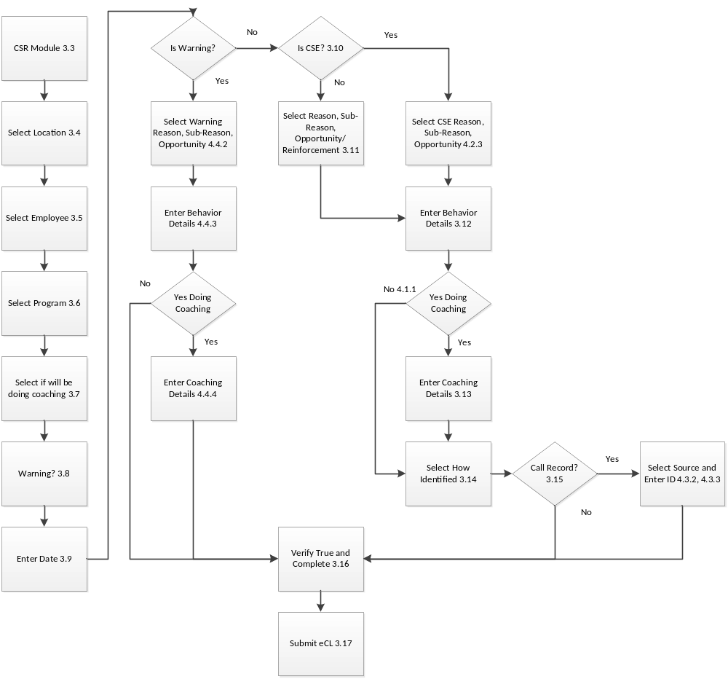
Figure 1 – CSR eCL Submission

